# 11040A Neural Networks

**Assignment 5**

**Deadline: July 3, 2025 24:00**

1. For a convolutional neural network in the following figure:

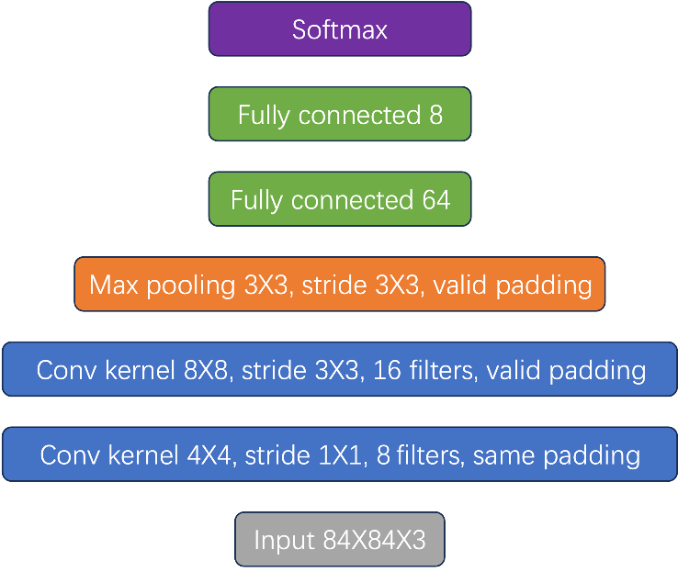

* 1. How many weights and biases are in this neural network? Please specify the number of weights and biases for each layer.
  2. Please describe the shapes of the outputs of each layer. (e.g. for the input layer, the shape is $84×84×1$)
  3. Please specify the size of receptive fields of the neurons after the max pooling layer.

1. Suppose there is a 1-D signal $[1,2,6,7,8,9,1]$ and a 1-D convolutional neural network.

The first convolutional layer has 4 filters, whose weights are $[0,1,0]$, $[0,0,1]$, $[1,0,0]$ and $[1,0,1]$, respectively.

The second convolutional layer has 1 filter, whose kernel size is 3 (you need to derive the depth of it yourself), and all the weights of it are 1.

All the biases are 0, all the strides are 1, all the padding strategies are valid padding, and there is no activation function in the neural network. Please specify the output of each filter respectively.

1. If we unroll an RNN through time, the diagram can be like the following figure.

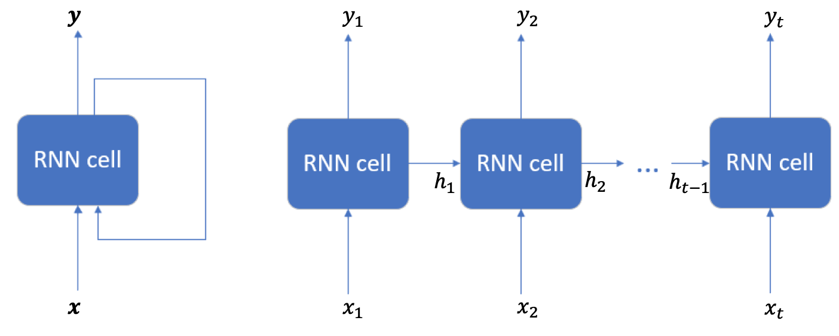

Deep RNNs stack RNN cells together, just like the following figure shows. Please depict the diagram of unrolling it through time.

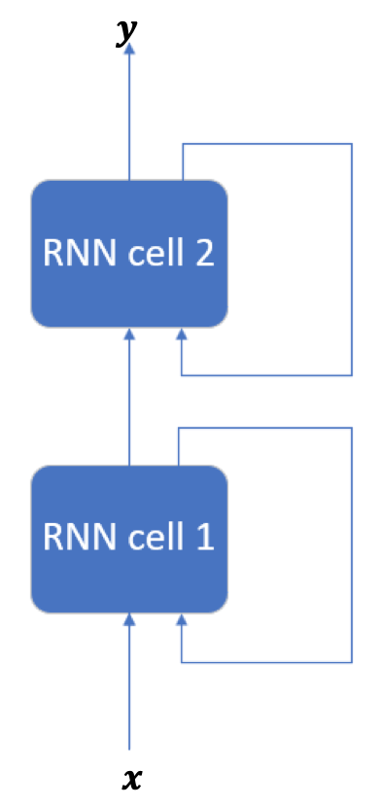

**Programming part**

Please write a report and send your report to TA. The report should include your code & results and the explanation of the code. If you have any questions, feel free to contact the TA.

(You can submit your programming files along with your report. Or you can organize your program into a markdown file or a Jupiter Notebook file as a report and submit it.)

Note: in this assignment, we recommend using deep learning frameworks if possible, such as TensorFlow, Torch, etc.

[MNIST dataset](http://yann.lecun.com/exdb/mnist/) is a well-known handwritten digit dataset. It consists of normalized and centered images with the size of $28×28$. There are 60,000 training samples and 10,000 test samples.

1. Download the dataset (you can use it directly in some deep learning framework) and split it into training set (50,000 samples), validation set (10,000 samples) and test set (10,000 samples).
2. Convolutional neural network (CNN) is a popular way to solve image classification problems. Implement a CNN and train it.
3. An image can be viewed as a sequence of vectors if you cut it along an axis (a $28×28$ matrix is comprised of 28 28-dim vectors). Implement a recurrent neural network for MNIST data and train it.
4. Choose one of the approaches above and try to improve it.

**The final video (due date: July 18, 2025)**

The final video includes two parts:

1. Choose one of the following topics and introduce it.
   1. Multi-layer perceptron and neural network optimization.
   2. Convolutional neural network.
   3. Recurrent neural network.
   4. Self-attention, Transformer and Generative AI
   5. Autoencoder and Deep Generative Models.
   6. Deep Reinforcement Learning.
2. Explain assignment 2, 4, 5 in your own words.

You can record your video by [zoom](https://ieeetv.ieee.org/mobile/video/recording-your-presentation-with-zoom).